Cropping, Copying and Pasting an Image Using OpenCV
Experiment No: 27
Aim
To perform cropping, copying, and pasting of a selected portion of an image inside another image using OpenCV in Python.
Tools Required
- Python 3.x
- OpenCV (cv2)
- NumPy
- VS Code / PyCharm / Jupyter Notebook
- Input images (image1.jpg and image2.jpg)
Procedure
- Install OpenCV and NumPy:
Bash
pip install opencv-python numpy
- Read the source and destination images using OpenCV.
- Select a rectangular region from the source image.
- Crop the selected region.
- Copy the cropped region.
- Select a suitable location in the destination image.
- Paste the copied region into the destination image.
- Display the original, cropped, and final images.
- Save the final image.
Code
import cv2

# Read the source and destination images
source = cv2.imread("image1.jpg")
destination = cv2.imread("image2.jpg")

# Check if images are loaded
if source is None:
print("Error: image1.jpg not found!")
exit()

if destination is None:
print("Error: image2.jpg not found!")
exit()

# Crop a region from the source image
# Format: image[y1:y2, x1:x2]
cropped = source[50:250, 50:250]

# Get dimensions of cropped image
h, w = cropped.shape[:2]

# Make sure the destination image is large enough
if h > destination.shape[0] or w > destination.shape[1]:
print("Cropped region is too large for destination image!")
exit()

# Copy and paste cropped image into destination
destination[50:50+h, 50:50+w] = cropped

# Display images
cv2.imshow("Source Image", source)
cv2.imshow("Cropped Image", cropped)
cv2.imshow("Final Image", destination)

# Save final image
cv2.imwrite("final_image.jpg", destination)

cv2.waitKey(0)
cv2.destroyAllWindows()
Output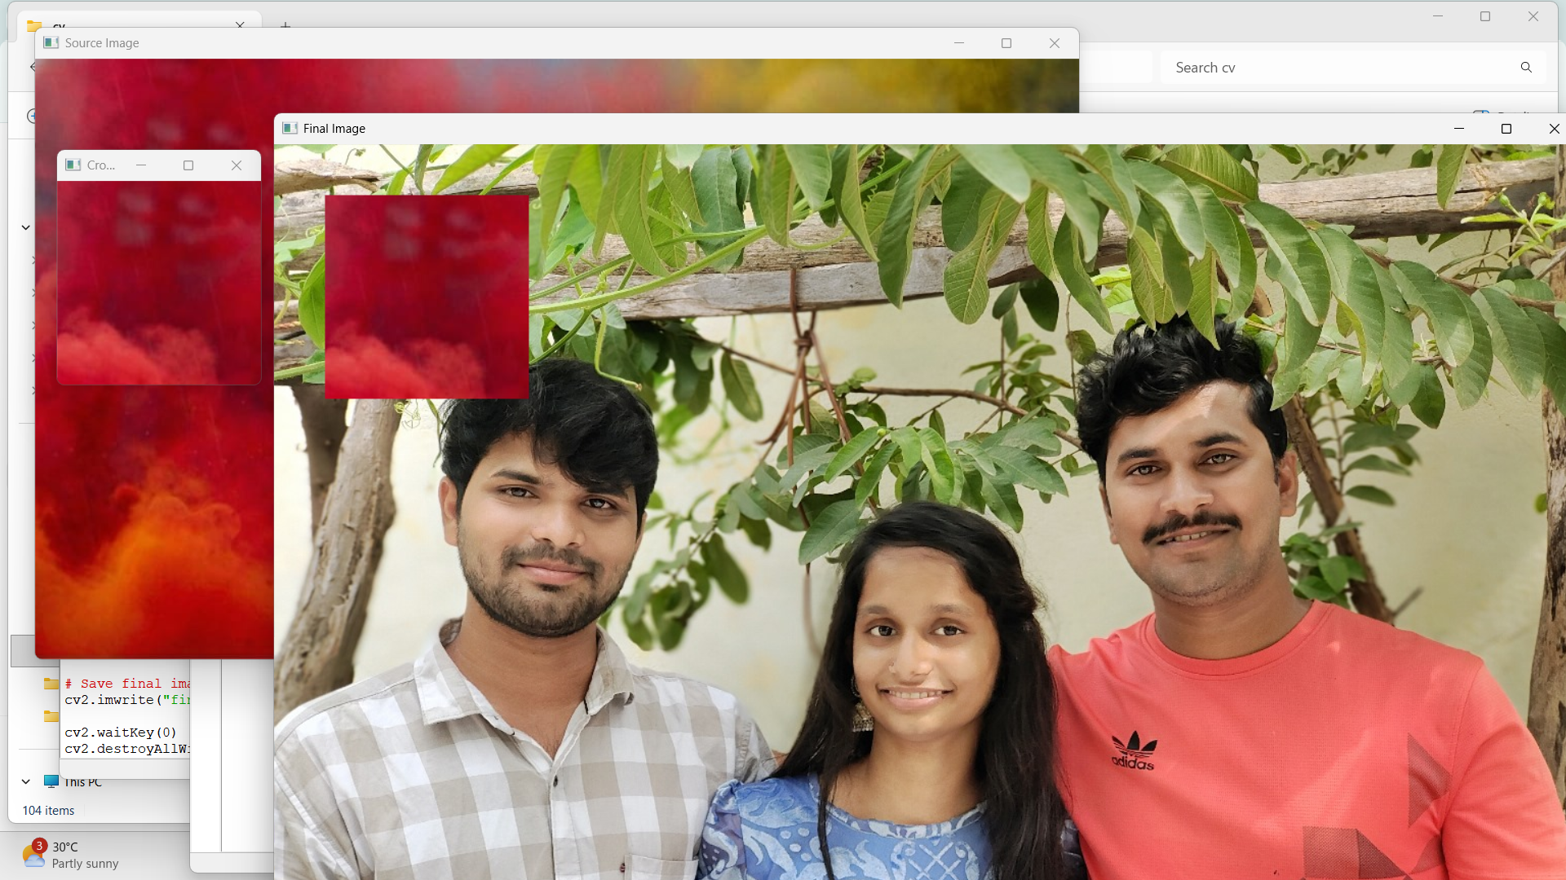
Result
The required cropping, copying, and pasting operations were successfully performed using OpenCV. A selected portion of the source image was cropped and pasted into another image at the specified location.

